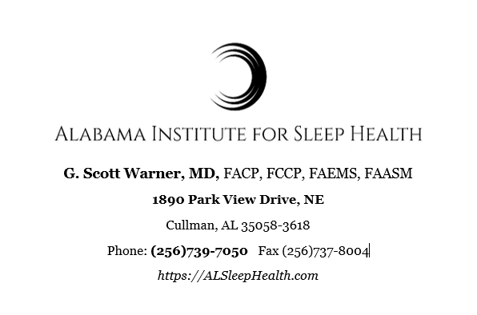

Nondiscrimination Policy

Alabama Institute for Sleep Health does not exclude, deny benefits to, or otherwise discriminate against any person on the ground of race, color, national origin, disability, age, gender or religion in admission to, participation in, or receipt of the services and benefits under any of its programs and activities, and in staff and employee assignments to patients, whether carried out by Alabama Institute for Sleep Health directly or through a contractor or any other entity with which Alabama Institute for Sleep Health arranges to carry out its programs and activities.
This statement is in accordance with the provisions of Title VI of the Civil Rights Act of 1964 (nondiscrimination on the basis of race, color, national origin), Section 504 of the Rehabilitation Act of 1973 (nondiscrimination on the basis of disability), the Age Discrimination Act of 1975 (nondiscrimination on the basis of age), regulations of the U.S. Department of Health and Human Services issued pursuant to these three statutes at Title 45 Code of Federal Regulations Parts 80, 84, and 91, (and state laws or corporate policies, etc.).
Additionally, in accordance with Section 1557 of the Patient Protection and Affordable Care Act of 2010, 42 U.S.C. § 18116, (name of provider) does not exclude, deny benefits to, or otherwise discriminate against any person on the ground of sex (including gender identity) in admission to, participation in, or receipt of the services and benefits under any of its health programs and activities, and in staff and employee assignments, whether carried out by (name of provider) directly or through a contractor or any other entity with which Alabama Institute for Sleep Health arranges to carry out its programs and activities.
In case of questions, please contact:
Provider Name: Alabama Institute for Sleep Health
Contact Person/Section 504 Coordinator: Tina Warner
Telephone number: 256-739-7050
TDD or State Relay number: 7-1-1 or 1-800-548-2546
You can also file a civil rights complaint with the U.S. Department of Health and Human Services, Office for Civil Rights, electronically through the Office for Civil Rights Complaint Portal, available at https://ocrportal.hhs.gov/ocr/portal/lobby.jsf, or by mail or phone at: U.S. Department of Health and Human Services 200 Independence Avenue, SW Room 509F, HHH Building Washington, D.C. 20201 1-800-368-1019, 800-537-7697 (TDD)

